U. S. Naval Academy
Information Forum

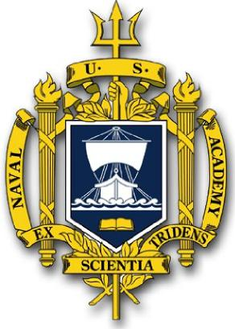

November 22, 2022 Roper YMCA
3:00 - 7:00 pm Winter Garden

Blue and Gold Officers:
Mrs. Annette Roehrbein
Mrs. Donna Miller

Midshipmen:
MIDN Martin Lopez (Oviedo HS)
MIDN Matthew Kousry (Poinciana HS)

When: November 22, 2022; 3:00 - 7:00 pm
Where: Roper YMCA, 100 Windermere Road, Winter Garden

Open to Interested Students (Grades 7-11) and Parents

Questions? Contact Annette Roehrbein AnnetteRoehrbeinBGO@gmail.com

